**Light Up the Green World . LED Downlights Expert 7 Years**

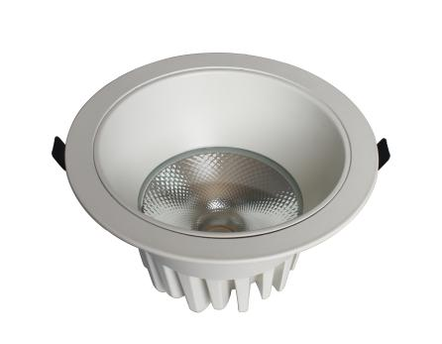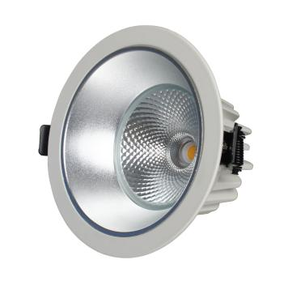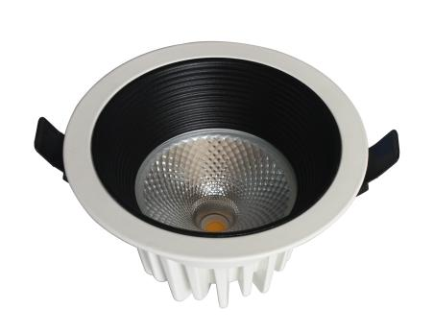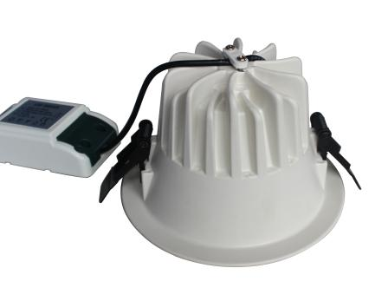

**1. Model No.** TD051A TD051B TD051D

**LED Downlight**

|  |  |  |  |  |  |  |  |  |  |  |
| --- | --- | --- | --- | --- | --- | --- | --- | --- | --- | --- |
| **Model No.** | **Power** | **Lumen(lm)** | **Driver Brand** | **LED Style** | **CCT(K)** | **Beam Angle** | **Power Factor** | **CRI** | **Size(mm)** | **Cutout(mm)** |
| TD051-2.5F | 5W | 400lm | Philips Driver | CREE COB | 3000K  4000K  5000K | 50° | >0.90 | Ra80/90 | ɸ89.7*H56 | ɸ75 |
| TD051-3F | 9W | 790lm | ɸ110*H68 | ɸ90 |
| TD051-4F | 15W | 1300lm | ɸ137.5*H82 | ɸ120 |
| TD051-5F | 20W | 1700lm | ɸ165*H91 | ɸ140 |
| TD051-6F | 30W | 2600lm | ɸ195*H107 | ɸ170 |
| TD051-8F | 40W | 3500lm | ɸ235*H127.5 | ɸ200 |

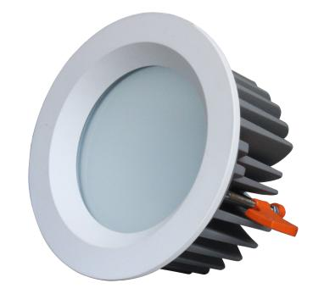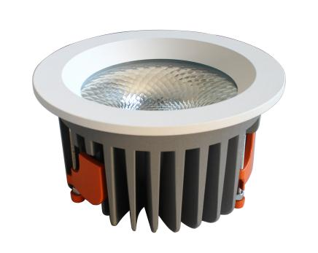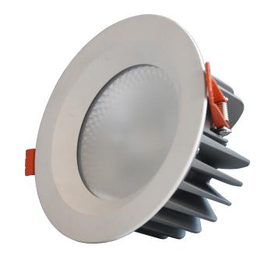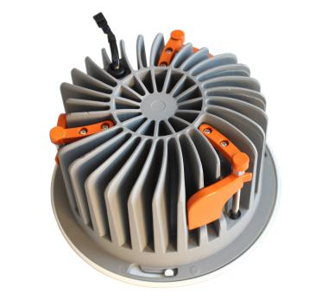

**2. Model No.** TD053A TD053B TD053C

**IP54 COB Downlight**

|  |  |  |  |  |  |  |  |  |  |  |
| --- | --- | --- | --- | --- | --- | --- | --- | --- | --- | --- |
| **Model No.** | **Power** | **Lumen(lm)** | **Driver Brand** | **LED Style** | **CCT(K)** | **Beam Angle** | **Power Factor** | **CRI** | **Size(mm)** | **Cutout(mm)** |
| TD053-3F | 10W | 850lm | Philips Driver | CREE COB | 3000K  4000K  5000K | 50° | >0.90 | Ra80/90 | ɸ110*H61 | ɸ95 |
| TD053-4F | 15W | 1300lm | ɸ135*H69 | ɸ110 |
| TD053-5F | 25W | 2200lm | ɸ160*H75 | ɸ130 |
| TD053-6F | 40W | 3500lm | ɸ185*H100 | ɸ165 |
| TD053-8F | 60W | 4800lm | ɸ240*H120 | ɸ205 |

**Warranty 3-5 Years**

**Light Up the Green World . LED Downlights Expert 7 Years**

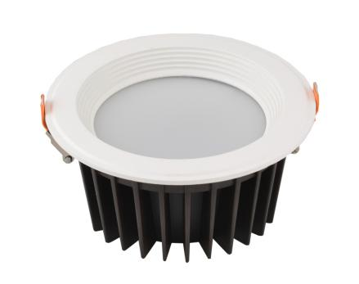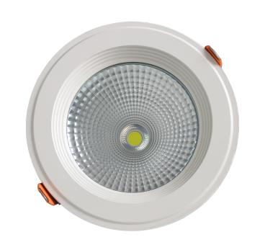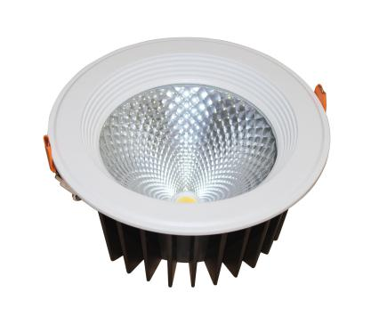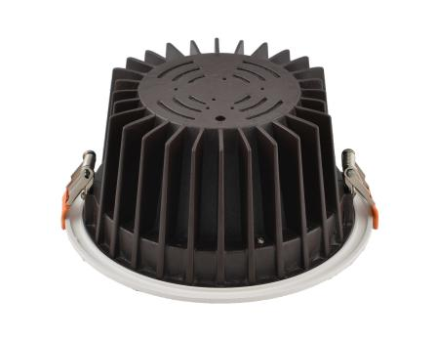

**3. Model No.** TD033A TD033B TD033C

**LED Downlight**

|  |  |  |  |  |  |  |  |  |  |  |
| --- | --- | --- | --- | --- | --- | --- | --- | --- | --- | --- |
| **Model No.** | **Power** | **Lumen(lm)** | **Driver Brand** | **LED Style** | **CCT(K)** | **Beam Angle** | **Power Factor** | **CRI** | **Size(mm)** | **Cutout(mm)** |
| TD033-3F | 9W | 750lm | Philips Driver | CREE COB | 3000K  4000K  5000K | 60° | >0.90 | Ra80/90 | ɸ108*H52 | ɸ95 |
| TD033-4F | 15W | 1300lm | ɸ142*H65 | ɸ125 |
| TD033-5F | 20W | 1700lm | ɸ158*H75 | ɸ140 |
| TD033-6F | 25W | 2200lm | ɸ185*H88 | ɸ170 |
| TD033-8F | 40W | 3500lm | ɸ226*H108 | ɸ210 |
| TD033-10F | 60W | 5000lm | ɸ282*H130 | ɸ265 |

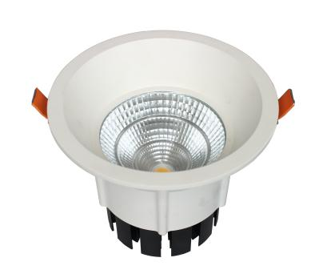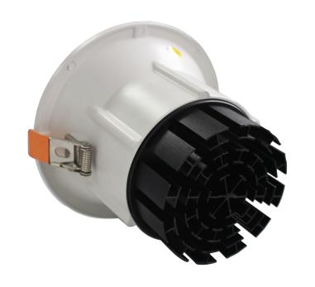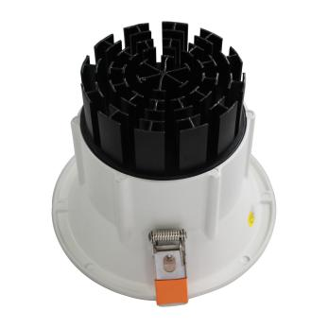

1. **Model No.** TD041

**Horn LED Downlight**

|  |  |  |  |  |  |  |  |  |  |  |
| --- | --- | --- | --- | --- | --- | --- | --- | --- | --- | --- |
| **Model No.** | **Power** | **Lumen(lm)** | **Driver Brand** | **LED Style** | **CCT(K)** | **Beam Angle** | **Power Factor** | **CRI** | **Size(mm)** | **Cutout(mm)** |
| TD041-3F | 9W | 750lm | Philips Driver | CREE COB | 3000K  4000K  5000K | 24°60° | >0.90 | Ra80/90 | ɸ105*H90.5 | ɸ95 |
| TD041-4F | 15W | 1300lm | ɸ139*H110.5 | ɸ125 |
| TD041-5F | 25W | 2200lm | ɸ162*H125.5 | ɸ140 |
| TD041-6F | 40W | 3500lm | ɸ185*H145 | ɸ170 |

**Warranty 3-5 Years**

**Light Up the Green World . LED Downlights Expert 7 Years**

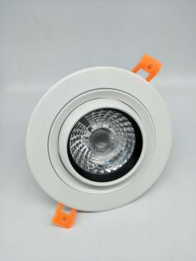 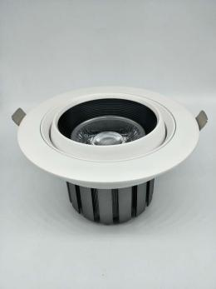 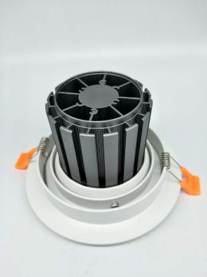 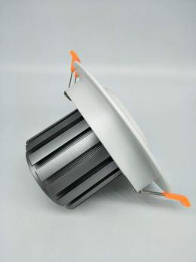 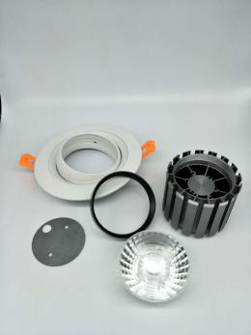

**5. Model No.** SD001

**LED Gimbal Downlight**

|  |  |  |  |  |  |  |  |  |  |  |
| --- | --- | --- | --- | --- | --- | --- | --- | --- | --- | --- |
| **Model No.** | **Power** | **Lumen(lm)** | **Driver Brand** | **LED Style** | **CCT(K)** | **Beam Angle** | **Power Factor** | **CRI** | **Size(mm)** | **Cutout(mm)** |
| SD001-3F | 7W | 550lm | Philips Driver | CREE COB | 3000K  4000K  5000K | 24° | >0.90 | Ra80/90 | ɸ86*H68 | ɸ70 |
| SD001-4F | 12W | 1000lm | ɸ118*H65 | ɸ90 |
| SD001-5F | 20W | 1700lm | ɸ140*H80 | ɸ120 |
| SD001-6F | 30W | 2500lm | ɸ160*H125 | ɸ145 |

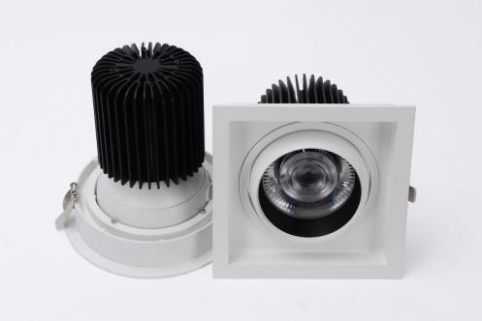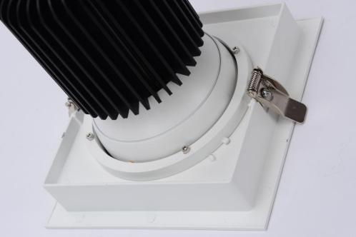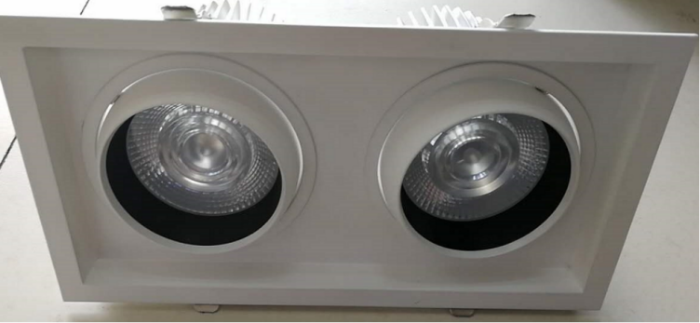

**6. Model No.** SD004

**LED Square Downlight**

|  |  |  |  |  |  |  |  |  |  |  |
| --- | --- | --- | --- | --- | --- | --- | --- | --- | --- | --- |
| **Model No.** | **Power** | **Lumen(lm)** | **Driver Brand** | **LED Style** | **CCT(K)** | **Beam Angle** | **Power Factor** | **CRI** | **Size(mm)** | **Cutout(mm)** |
| SD004A | 30W | 2400lm | Philips Driver | CREE COB | 3000K  4000K  5000K | 12°24°36° | >0.90 | Ra80/90 | SQ175*H145 | 150*150 |
| SD004B | 50W | 4000lm | SQ175*H180 | 150*150 |
| SD004C | 2*30W | 2*2400lm | 175*325*H145 | 150*300 |
| SD004D | 2*50W | 2*4000lm | 175*325*H180 | 150*300 |

**Warranty 3-5 Years**

**Light Up the Green World . LED Downlights Expert 7 Years**

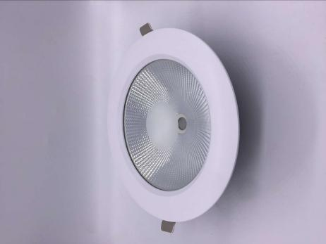 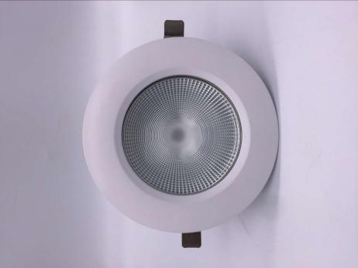 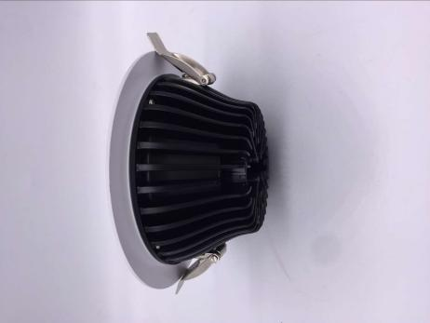 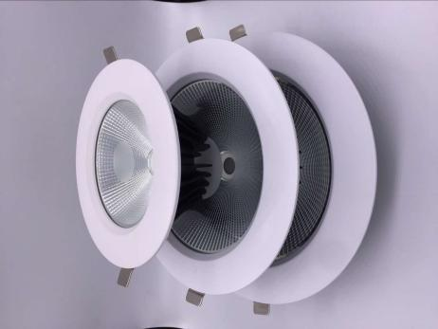

**7. Model No.** TD056

**SMD COB Downlight**

|  |  |  |  |  |  |  |  |  |  |  |
| --- | --- | --- | --- | --- | --- | --- | --- | --- | --- | --- |
| **Model No.** | **Power** | **Lumen(lm)** | **Driver Brand** | **LED Style** | **CCT(K)** | **Beam Angle** | **Power Factor** | **CRI** | **Size(mm)** | **Cutout(mm)** |
| TD056-4F | 12W | 100lm | Philips Driver | SanAnCOB | 3000K  4000K  6000K | 60° | >0.90 | Ra80/90 | ɸ148*H63 | ɸ125 |
| TD056-6F | 20W | 1600lm | ɸ195*H63 | ɸ168 |
| TD056-8F | 30W | 2400lm | ɸ230*H63 | ɸ190 |
| TD056-10F | 30W | 2400lm | ɸ280*H88 | ɸ195 |

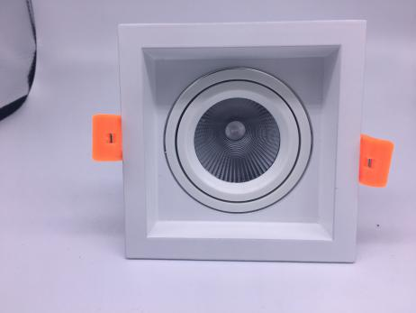 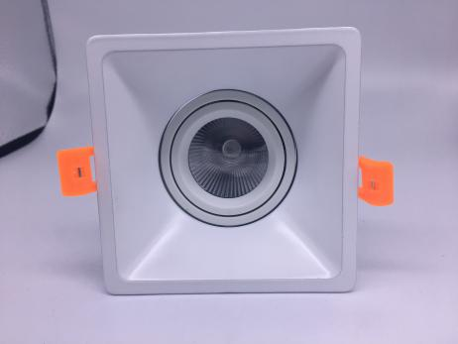 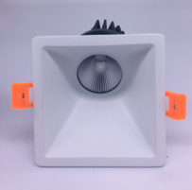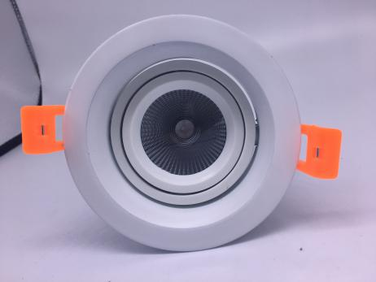

**Model No.** DLM001-A DLM001-B DLM001-C DLM001-D

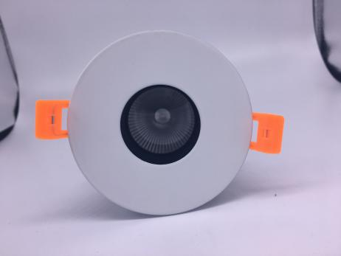 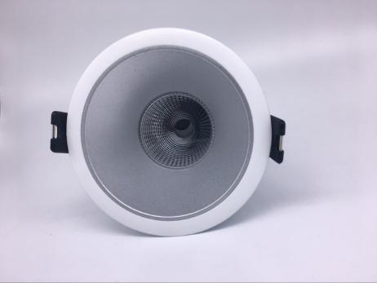 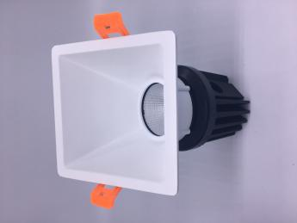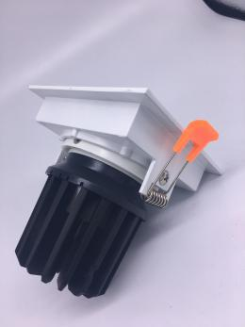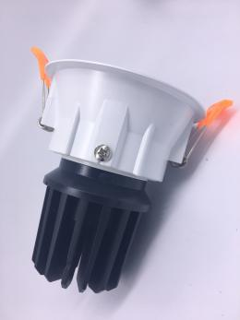

**8. Model No.** DLM001-E DLM001-F DLM001-C

**Modular Downlight**

**Light Up the Green World . LED Downlights Expert 7 Years**

|  |  |  |  |  |  |  |  |  |  |  |
| --- | --- | --- | --- | --- | --- | --- | --- | --- | --- | --- |
| **Model No.** | **Power** | **Lumen(lm)** | **Driver Brand** | **LED Style** | **CCT(K)** | **Beam Angle** | **Power Factor** | **CRI** | **Size(mm)** | **Cutout(mm)** |
| DLM001-A | 10W | 850lm | Philips Driver | CREE COB | 3000K  4000K  6000K | 15°24°36° | >0.90 | Ra80/90 | SQ95*H98 | 85*85 |
| 15W | 1300lm | SQ95*H103 |
| DLM001-B | 10W | 850lm | SQ105*H113 | 95*95 |
| 15W | 1300lm | SQ105*H118 |
| DLM001-C | 10W | 850lm | SQ95*H118 | 85*85 |
| 15W | 1300lm | SQ95*H123 |
| DLM001-D | 10W | 850lm | ɸ95*H98 | ɸ85 |
| 15W | 1300lm | ɸ95*H103 |
| DLM001-E | 10W | 850lm | ɸ90*H105 | ɸ80 |
| 15W | 1300lm | ɸ90*H110 |
| DLM001-F | 10W | 850lm | ɸ85*H105 | ɸ77 |
| 15W | 1300lm | ɸ85*H112 |

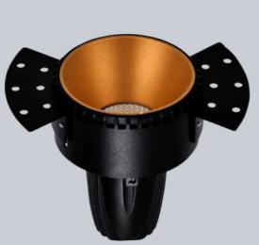 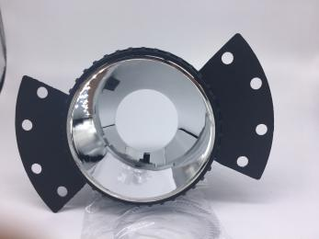 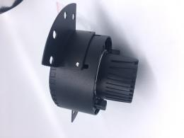 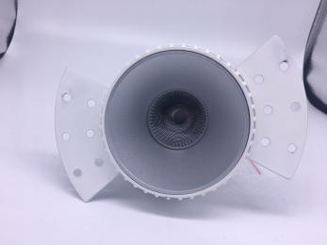 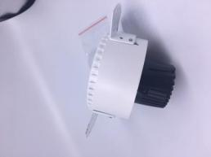

**9. Model No.** DLM002

**Trimless Modular Downlight**

|  |  |  |  |  |  |  |  |  |  |  |
| --- | --- | --- | --- | --- | --- | --- | --- | --- | --- | --- |
| **Model No.** | **Power** | **Lumen(lm)** | **Driver Brand** | **LED Style** | **CCT(K)** | **Beam Angle** | **Power Factor** | **CRI** | **Size(mm)** | **Cutout(mm)** |
| DLM002-A | 5W | 400lm | Philips Driver | CREE COB | 3000K  4000K  6000K | 15°24°38°  55° | >0.90 | Ra80/90 | ɸ91*H78 | ɸ92 |
| DLM002-B | 10W | 800lm | ɸ91*H115 |

**Warranty 3-5 Years**

**Light Up the Green World . LED Downlights Expert 7 Years**

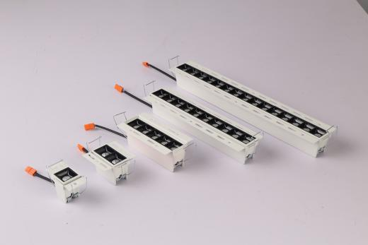 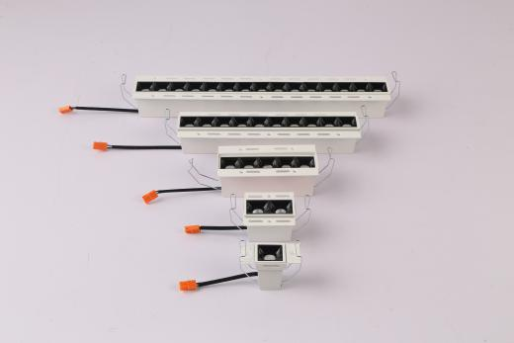 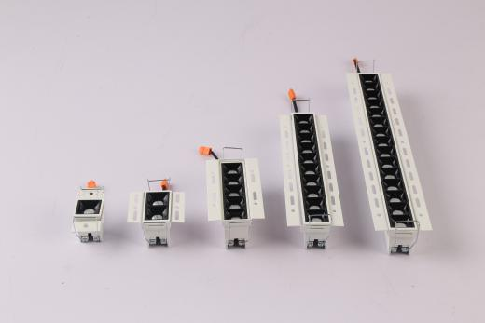

**10. Model No.** XTD-B

**Trimless Linear Downlight**

|  |  |  |  |  |  |  |  |  |  |  |
| --- | --- | --- | --- | --- | --- | --- | --- | --- | --- | --- |
| **Model No.** | **Power** | **Lumen(lm)** | **Driver Brand** | **LED Style** | **CCT(K)** | **Beam Angle** | **Power Factor** | **CRI** | **Size(mm)** | **Cutout(mm)** |
| XTD-B-01 | 2W*1 | 150lm | Philips Driver | CREE Osram | 3000K  4000K  5000K | 15°30°45° | >0.90 | Ra80/90 | 35*35*H49 | 42*42 |
| XTD-B-02 | 2W*2 | 300lm | 65*35*H49 | 72*42 |
| XTD-B-05 | 2W*5 | 800lm | 138*35*H49 | 144*42 |
| XTD-B-10 | 2W*10 | 1700lm | 270*35*H49 | 277*42 |
| XTD-B-15 | 2W*15 | 2500lm | 403*35*H49 | 409*42 |

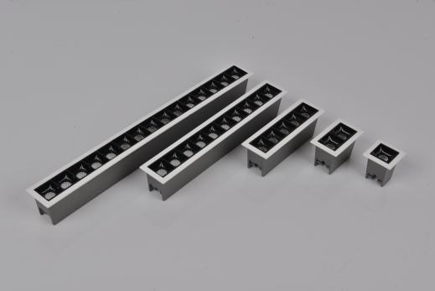 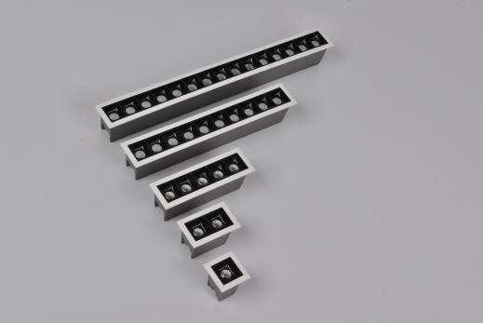 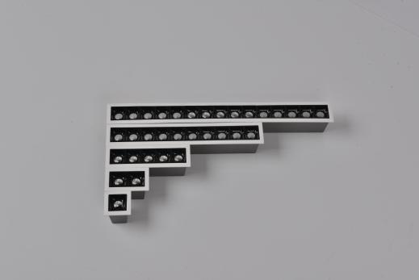

**11. Model No.** XTD-A

**LED Linear Downlight with Trim**

|  |  |  |  |  |  |  |  |  |  |  |
| --- | --- | --- | --- | --- | --- | --- | --- | --- | --- | --- |
| **Model No.** | **Power** | **Lumen(lm)** | **Driver Brand** | **LED Style** | **CCT(K)** | **Beam Angle** | **Power Factor** | **CRI** | **Size(mm)** | **Cutout(mm)** |
| XTD-A-01 | 2W*1 | 150lm | Philips Driver | CREE Osram | 3000K  4000K  5000K | 15°30°45° | >0.90 | Ra80/90 | 45*45*H49 | 37*37 |
| XTD-A-02 | 2W*2 | 300lm | 75*45*H49 | 68*37 |
| XTD-A-05 | 2W*5 | 800lm | 147*45*H49 | 140*37 |
| XTD-A-10 | 2W*10 | 1700lm | 280*45*H49 | 273*37 |
| XTD-A-15 | 2W*15 | 2500lm | 415*45*H49 | 405*37 |

**Warranty 3-5 Years**

**Light Up the Green World . LED Downlights Expert 7 Years**

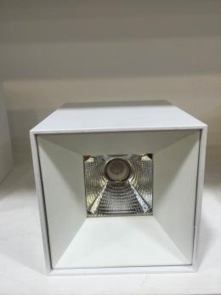 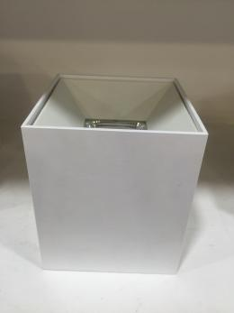 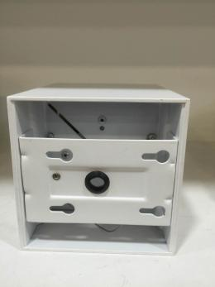 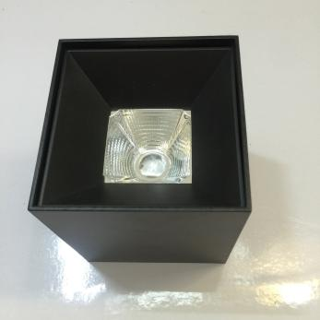 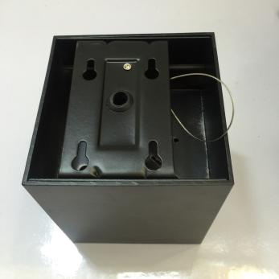

**12. Model No.** SMDL001

**Square Surface Mounted Downlight**

|  |  |  |  |  |  |  |  |  |  |  |
| --- | --- | --- | --- | --- | --- | --- | --- | --- | --- | --- |
| **Model No.** | **Power** | **Lumen(lm)** | **Driver Brand** | **LED Style** | **CCT(K)** | **Beam Angle** | **Power Factor** | **CRI** | **Size(mm)** | **Height(mm)** |
| SMDL001-4F | 10W | 850lm | Philips Driver | CREE | 3000K  4000K  5000K | 24° | >0.90 | Ra80/90 | 80*80 | 103 |
| SMDL001-5F | 15W | 1300lm | 100*100 | 112 |
| SMDL001-6F | 20W | 1700lm | 120*120 | 133 |
| SMDL001-8F | 30W | 2500lm | 150*150 | 142 |

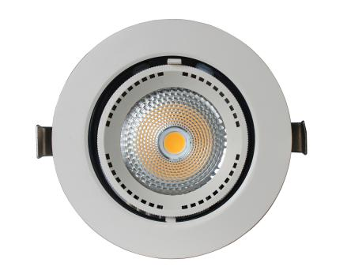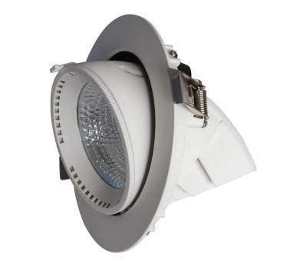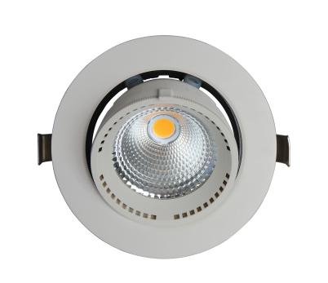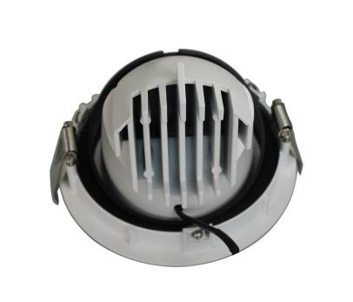

**13. Model No.** SD002

**LED Gimbal Downlight**

|  |  |  |  |  |  |  |  |  |  |  |
| --- | --- | --- | --- | --- | --- | --- | --- | --- | --- | --- |
| **Model No.** | **Power** | **Lumen(lm)** | **Driver Brand** | **LED Style** | **CCT(K)** | **Beam Angle** | **Power Factor** | **CRI** | **Size(mm)** | **Cutout(mm)** |
| SD002-2.5F | 7W | 550lm | Philips Driver | CREE COB | 3000K  4000K  5000K | 24° | >0.90 | Ra80/90 | ɸ85*H78 | ɸ76 |
| SD002-4F | 15W | 1300lm | ɸ130*H110 | ɸ120 |
| SD002-5F | 30W | 2500lm | ɸ165*H143 | ɸ155 |
| SD002-6F | 40W | 3500lm | ɸ190*H155 | ɸ170 |

**Warranty 3-5 Years**

**Light Up the Green World . LED Downlights Expert 7 Years**

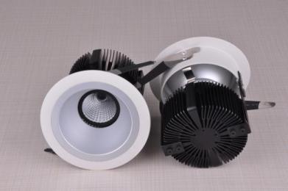 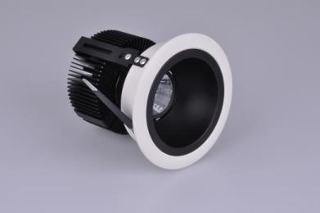 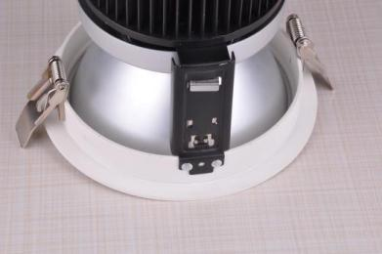 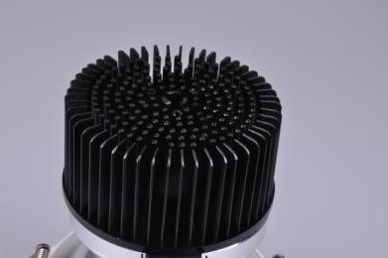

**14. Model No.** HSTD001

**LED Wall Washer Downlight**

|  |  |  |  |  |  |  |  |  |  |  |
| --- | --- | --- | --- | --- | --- | --- | --- | --- | --- | --- |
| **Model No.** | **Power** | **Lumen(lm)** | **Driver Brand** | **LED Style** | **CCT(K)** | **Beam Angle** | **Power Factor** | **CRI** | **Size(mm)** | **Cutout(mm)** |
| HSTD001-A | 10W | 850lm | Philips Driver | CREE | 3000K  4000K  5000K | 24°  38° | >0.90 | Ra80/90 | D90*H113 | D78 |
| HSTD001-B | 15W | 1300lm | D90*H134 | D78 |
| HSTD001-C | 20W | 1700lm | D120*H116 | D100 |
| HSTD001-D | 40W | 3500lm | D160*H156 | D140 |

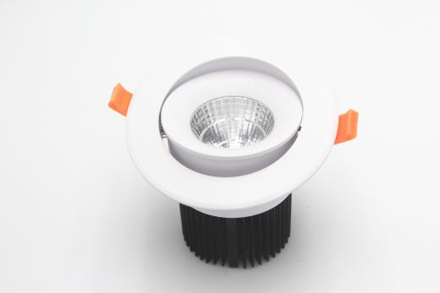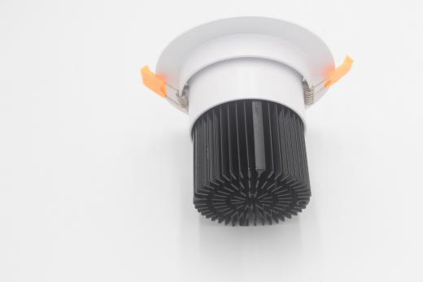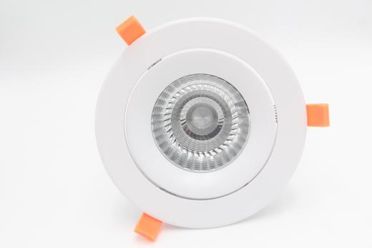

**15. Model No.** ATD001

**Adjustable LED Downlight**

|  |  |  |  |  |  |  |  |  |  |  |
| --- | --- | --- | --- | --- | --- | --- | --- | --- | --- | --- |
| **Model No.** | **Power** | **Lumen(lm)** | **Driver Brand** | **LED Style** | **CCT(K)** | **Beam Angle** | **Power Factor** | **CRI** | **Size(mm)** | **Cutout(mm)** |
| ATD001-A | 10W | 850lm | Philips Driver | CREE  CITIZEN | 3000K  4000K  5000K | 24°  60° | >0.90 | Ra80/90 | D111*H90 | D80 |
| ATD001-B | 15W | 1300lm | D120*H105 | D90 |
| ATD001-C | 20W | 1700lm | D142*H120 | D110 |
| ATD001-D1/D2 | 30W 40W | 2500lm 3400lm | D180*H130 | D145/D160 |
| ATD001-E1 | 40W | 3400lm | D194*H135 | D160 |

**Warranty 3-5 Years**

**Light Up the Green World . LED Downlights Expert 7 Years**

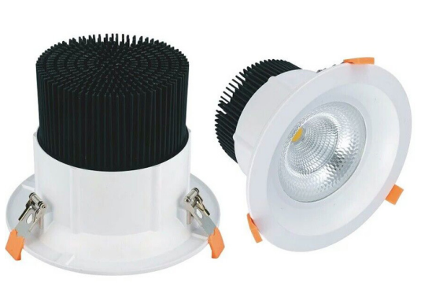

**16. Model No.** TD057

**LED Downlight with Lens**

|  |  |  |  |  |  |  |  |  |  |  |
| --- | --- | --- | --- | --- | --- | --- | --- | --- | --- | --- |
| **Model No.** | **Power** | **Lumen(lm)** | **Driver Brand** | **LED Style** | **CCT(K)** | **Beam Angle** | **Power Factor** | **CRI** | **Size(mm)** | **Cutout(mm)** |
| TD057-A | 15W | 1300lm | Philips Driver | CREE | 3000K  4000K  5000K | 24°  38°60° | >0.90 | Ra80/90 | D115*H80 | D95 |
| TD057-B | 30W | 2500lm | D142*H101 | D125 |
| TD057-C | 40W | 3300lm | D160*H133 | D140 |

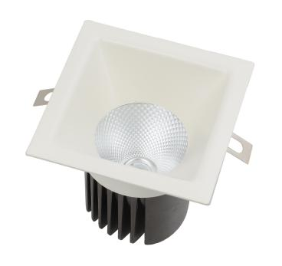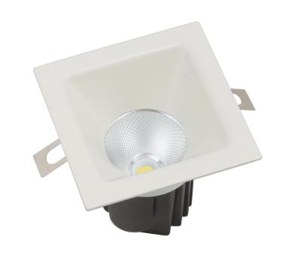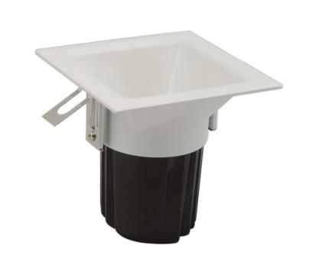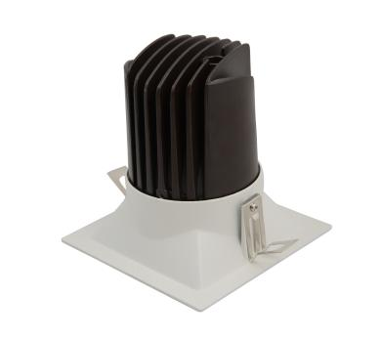

**17. Model No.** TSD0808

**Oblique Downlight Square**

|  |  |  |  |  |  |  |  |  |  |  |
| --- | --- | --- | --- | --- | --- | --- | --- | --- | --- | --- |
| **Model No.** | **Power** | **Lumen(lm)** | **Driver Brand** | **LED Style** | **CCT(K)** | **Beam Angle** | **Power Factor** | **CRI** | **Size(mm)** | **Cutout(mm)** |
| TSD0808-A | 10W | 800lm | Philips Driver | CREE | 3000K  4000K  5000K | 24° | >0.90 | Ra80/90 | SQ95*H98 | 80*80 |
| TSD0808-B | 15W | 1200lm | SQ115*H120 | 100*100 |

**Warranty 3-5 Years**

**Light Up the Green World . LED Downlights Expert 7 Years**

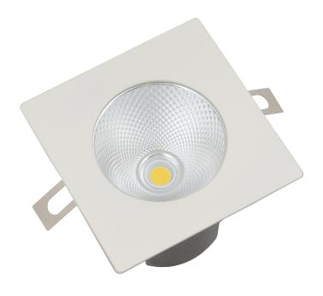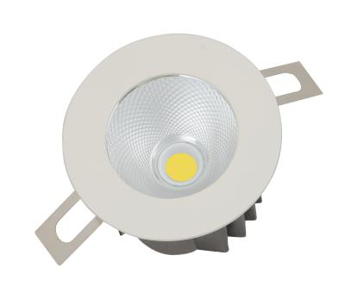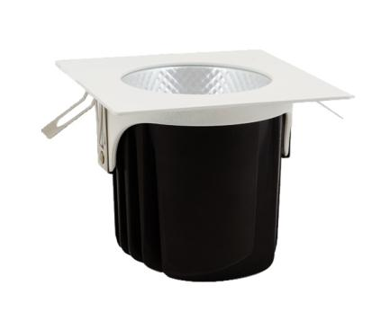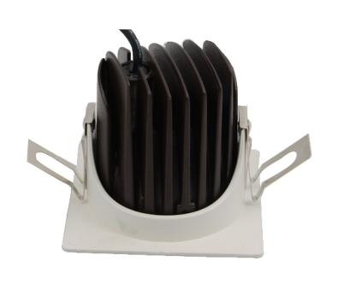

**18. Model No.** TSD0816

**Spot Downlight**

|  |  |  |  |  |  |  |  |  |  |  |
| --- | --- | --- | --- | --- | --- | --- | --- | --- | --- | --- |
| **Model No.** | **Power** | **Lumen(lm)** | **Driver Brand** | **LED Style** | **CCT(K)** | **Beam Angle** | **Power Factor** | **CRI** | **Size(mm)** | **Cutout(mm)** |
| TSD0816-A | 10W | 850lm | Philips Driver | CREE | 3000K  4000K  5000K | 24° | >0.90 | Ra80/90 | SQ75*H65 | D70 |
| TSD0816-B | 15W | 1300lm | SQ100*H85 | D90 |
| TSD0816-C | 20W | 1700lm | SQ135*H110 | D115 |

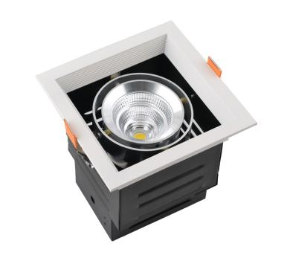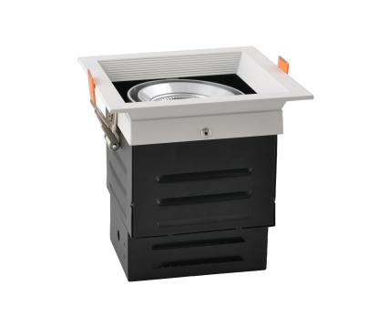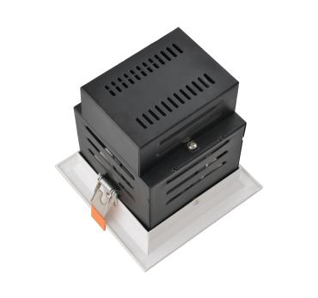

**19. Model No.** DD001-1

**LED Grille Light 1 Head**

|  |  |  |  |  |  |  |  |  |  |  |
| --- | --- | --- | --- | --- | --- | --- | --- | --- | --- | --- |
| **Model No.** | **Power** | **Lumen(lm)** | **Driver Brand** | **LED Style** | **CCT(K)** | **Beam Angle** | **Power Factor** | **CRI** | **Size(mm)** | **Cutout(mm)** |
| DD001-1-A | 10W | 850lm | Philips Driver | CREE  CITIZEN | 3000K  4000K  5000K | 24°  60° | >0.90 | Ra80/90 | SQ140*H144 | 125*125 |
| DD001-1-B | 15W | 1300lm | SQ160*H163 | 145*145 |
| DD001-1-C | 25W | 2200lm | SQ190*H173 | 170*170 |
| DD001-1-D | 40W | 3400lm | SQ203*H188 | 185*185 |

**Warranty 3-5 Years**

**Light Up the Green World . LED Downlights Expert 7 Years**

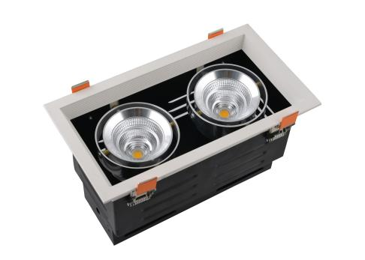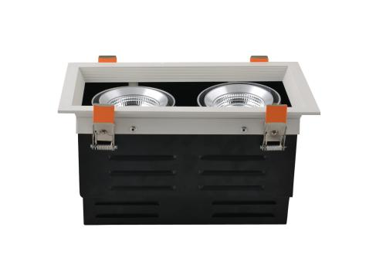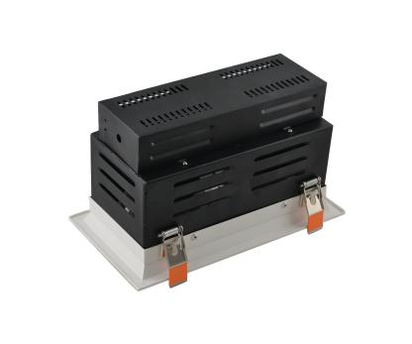

**20. Model No.** DD001-2

**LED Grille Light 2 Heads**

|  |  |  |  |  |  |  |  |  |  |  |
| --- | --- | --- | --- | --- | --- | --- | --- | --- | --- | --- |
| **Model No.** | **Power** | **Lumen(lm)** | **Driver Brand** | **LED Style** | **CCT(K)** | **Beam Angle** | **Power Factor** | **CRI** | **Size(mm)** | **Cutout(mm)** |
| DD001-2-A | 2*10W | 2*850lm | Philips Driver | CREE  CITIZEN | 3000K  4000K  5000K | 24°  60° | >0.90 | Ra80/90 | 260*140*H144 | 245*125 |
| DD001-2-B | 2*15W | 2*1300lm | 320*160*H163 | 305*145 |
| DD001-2-C | 2*25W | 2*2200lm | 375*190*H173 | 355*170 |
| DD001-2-D | 2*40W | 2*3400lm | 405*203*H188 | 385*185 |

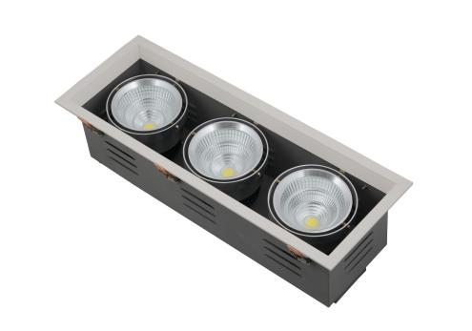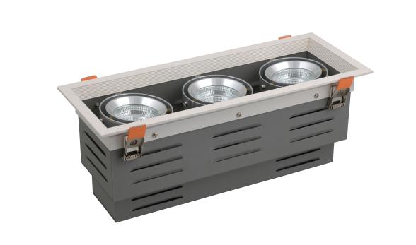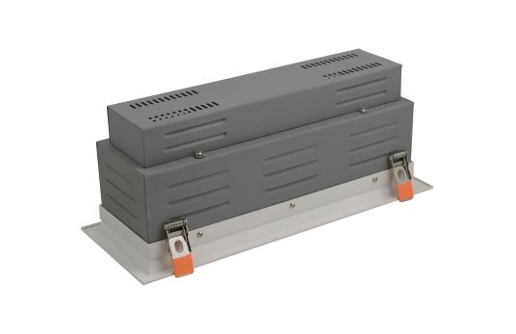

**21. Model No.** DD001-3

**LED Grille Light 3 Heads**

|  |  |  |  |  |  |  |  |  |  |  |
| --- | --- | --- | --- | --- | --- | --- | --- | --- | --- | --- |
| **Model No.** | **Power** | **Lumen(lm)** | **Driver Brand** | **LED Style** | **CCT(K)** | **Beam Angle** | **Power Factor** | **CRI** | **Size(mm)** | **Cutout(mm)** |
| DD001-3-A | 3*10W | 3*850lm | Philips Driver | CREE  CITIZEN | 3000K  4000K  5000K | 24°  60° | >0.90 | Ra80/90 | 372*140*H144 | 360*125 |
| DD001-3-B | 3*15W | 3*1300lm | 462*160*H163 | 450*145 |
| DD001-3-C | 3*25W | 3*2200lm | 538*190*H173 | 520*170 |

**Warranty 3-5 Years**